**Name: Stebin Babu**

**Roll No: 44**

**Batch: B**

**Date: 25/04/2022**

**NETWORKING & SYSTEM ADMINISTRATION LAB**

**Experiment No.: 3**

**Aim**

Familiarization of the linux commands.

**Procedure**

**59. sudo useradd**

This command is used to perform admin privileges.

Syntax :- $ sudo useradd <username>

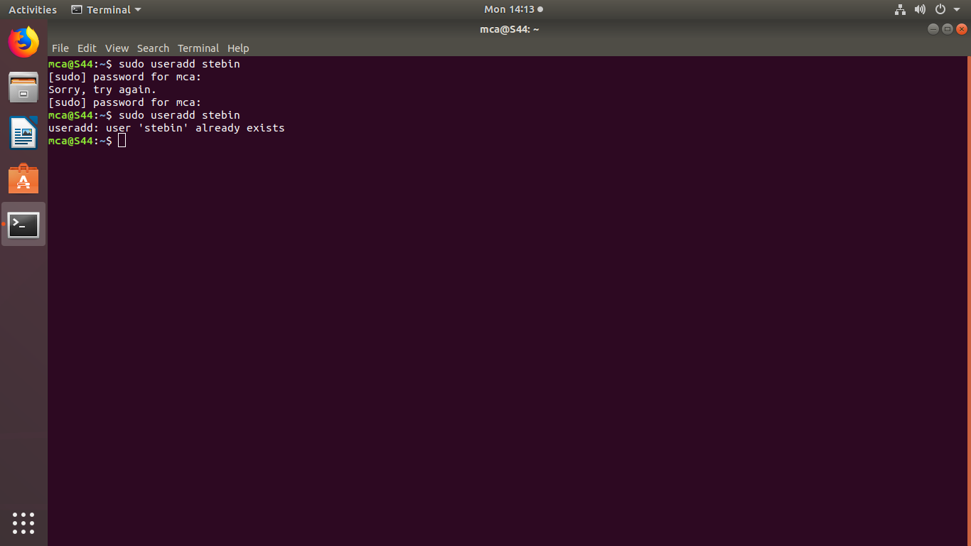 Output :-

**60. sudo passwd**

This command is used to provide password to the user.

Syntax :- $ sudo passwd <username>

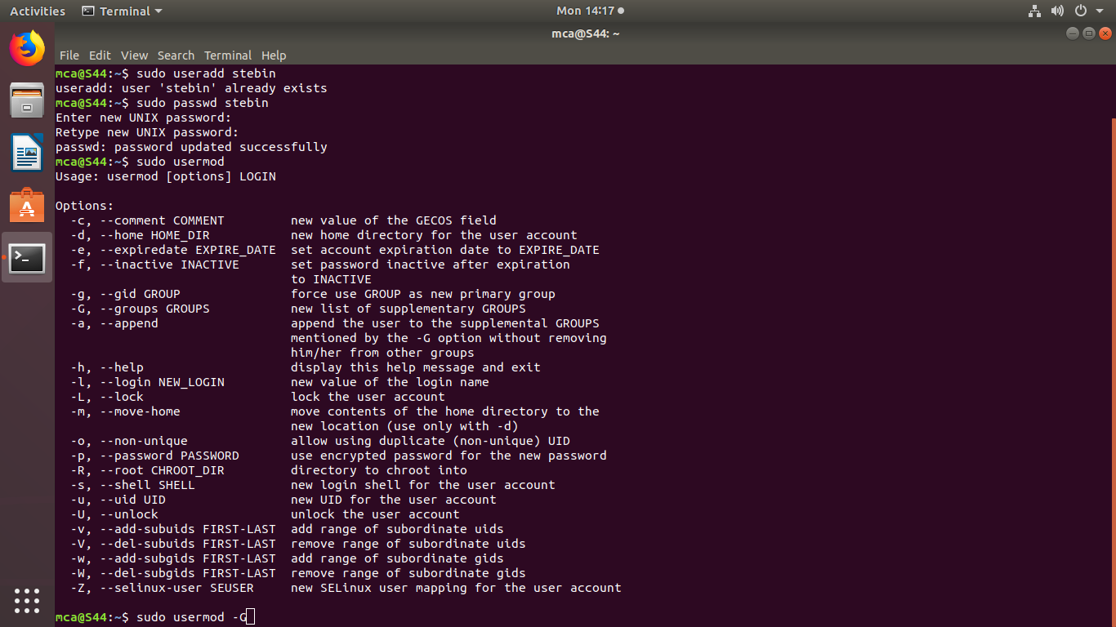 Output :-

**61. sudo groupadd -g**

This command is used to create a group.

Syntax :- $ sudo groupadd -g <id> <groupname>

Output :-

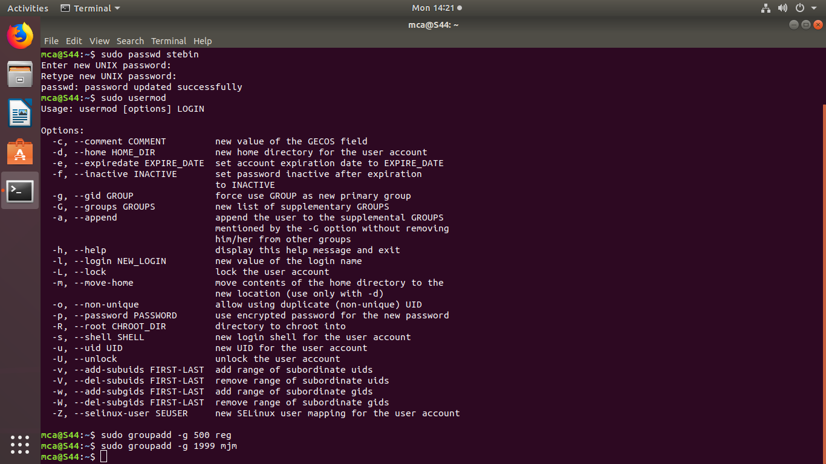

**62. sudo usermod -G**

This command is used to add user to a particular group.

Syntax :- $ sudo usermod -G <groupname> <username>

Output :-

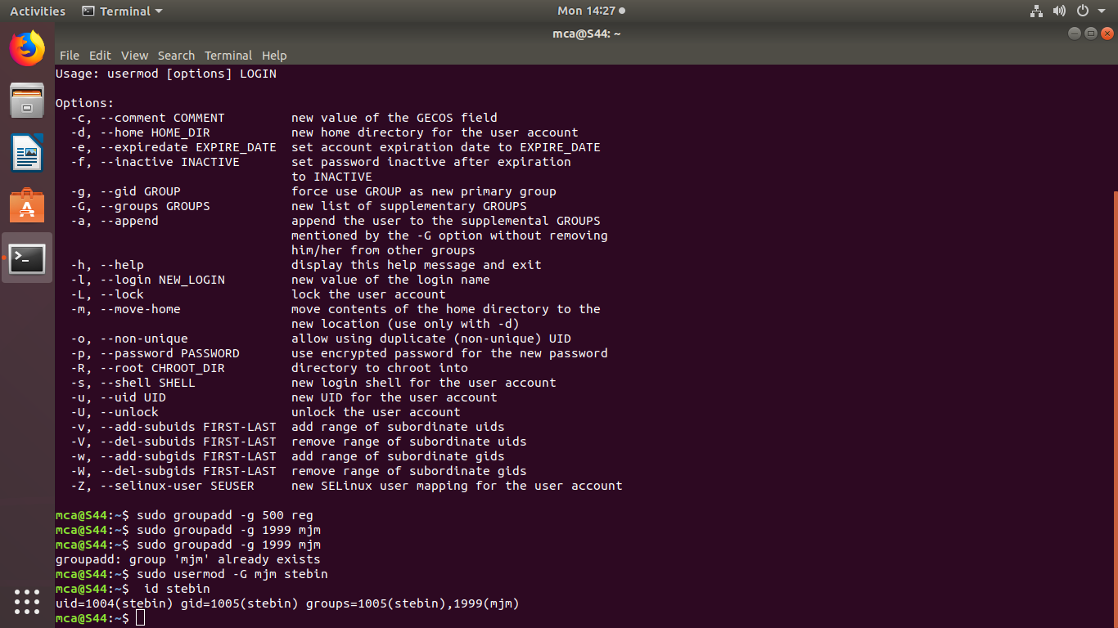

**63. id**

This command is used to display to which group the specified user exist.

Syntax :- $ id <username>

 Output:

**64. compgen -g**

This command is used to display all the groups that has been created.

Syntax :- $ compgen -g

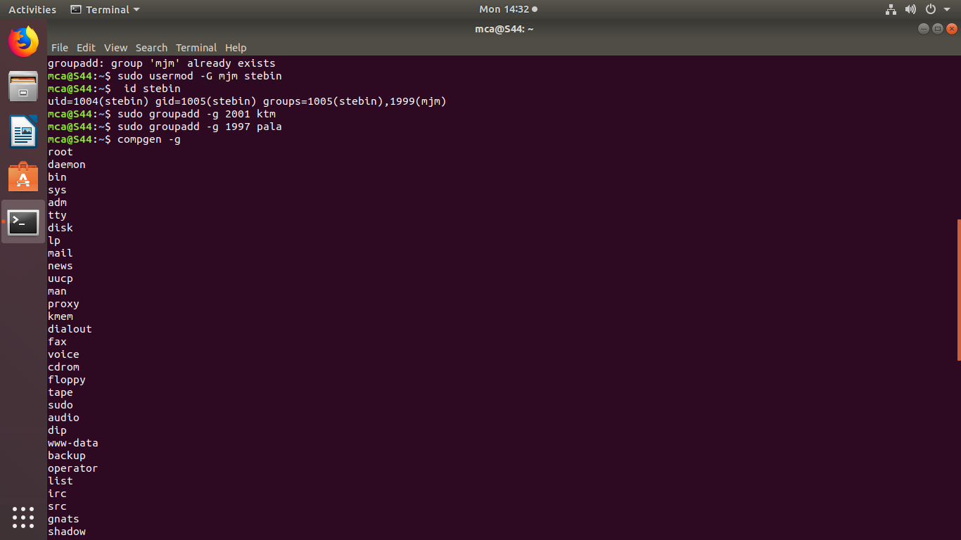 Output :-

**65. sudo userdel**

This command is used to delete a particular user.

Syntax :- $ sudo userdel <username>

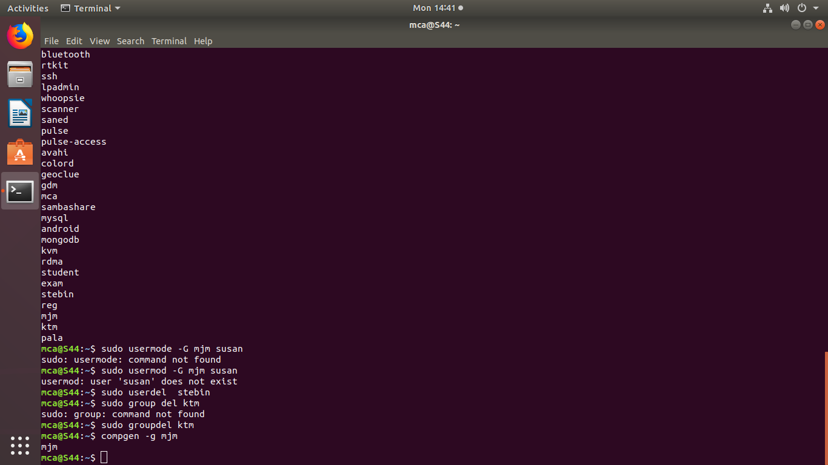Output :

**66. sudo groupdel**

This command is used to delete a particular group.

Syntax :- $ sudo groupdel <groupname>

 Output :-

**67. compgen -g <groupname>**

This command is used to display all the related groups with the name provided.

Syntax :- $ compgen -g <groupname>

Output :-

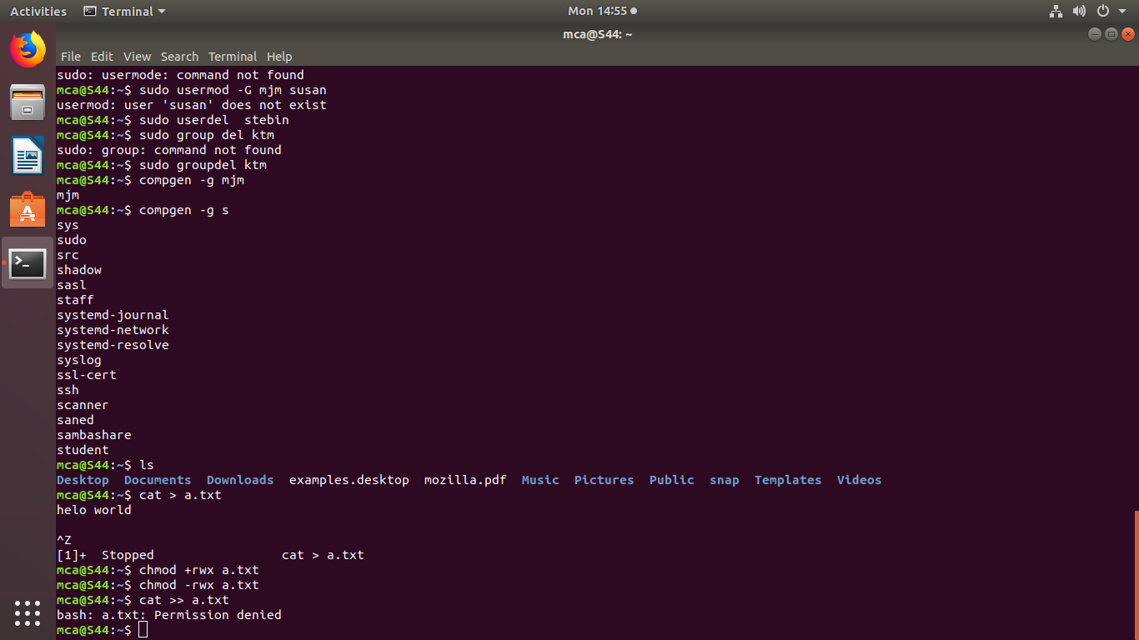

**68. chmod +rwx**

This command is used to allow the specified file to modify.

Syntax :- $ chmod +rwx <filename>

Output :-

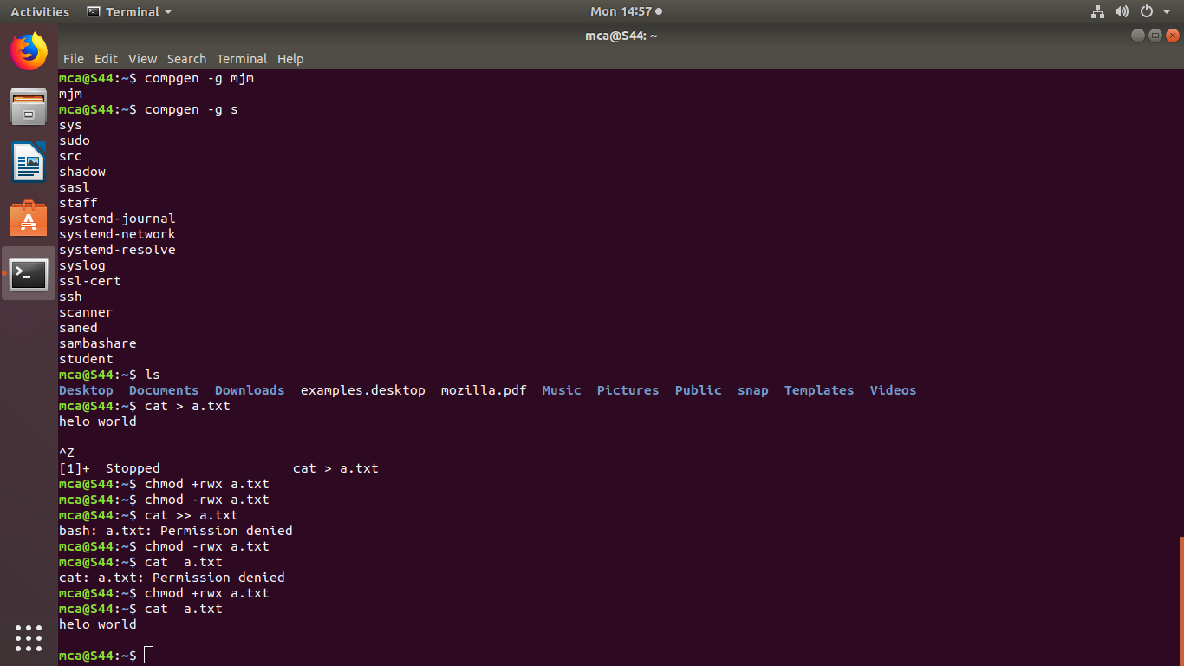

**69. chmod -rwx**

This command is used to deny the modification of the specified file.

Syntax :- $ chmod -rwx <filename>

Output :-



**70. sudo chown**

This command is used to change the owner of a file.

Syntax :- $ sudo chown <username> <filename>

Output :-

